Crash Severity Detection System (CSDS)

Crash Severity Detection (CSD) is a complex system that utilizes various sensors and algorithms to estimate the severity of a traffic accident in real-time.

Imagine a world where emergency responders instantly know the seriousness of a crash before they even arrive, allowing them to prioritize resources and potentially save lives.

That's the power of CSDS.

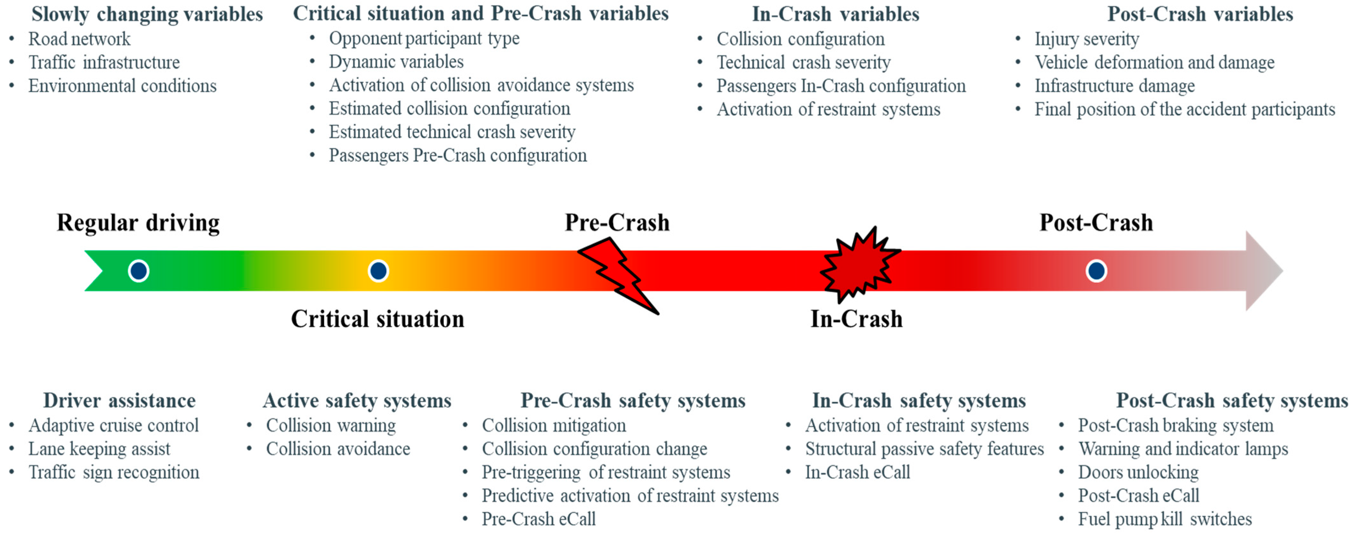

Benefits of CSDS:

* Faster response times for critical accidents
* Improved resource allocation for emergency services
* Enhanced preparation for first responders
* Valuable data for accident analysis and prevention
* Potential for reducing accidents and saving lives

**Working Principle of Crash Severity Detection (CSD)**

The crucial information obtained via CSDS helps emergency responders prioritize dispatch and allocate resources effectively, potentially saving lives.

Here's a breakdown of the working principle:

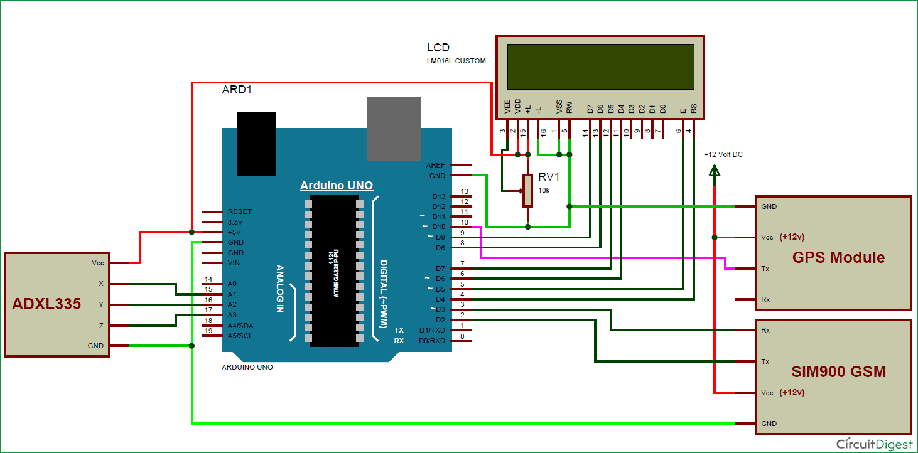

We will be using an Arduino Uno, collision detection sensor, FSR and a GPS module to capture the co-ordinates of the location.

These values will be processed by a python script and will be stored in a database. These database values will be updated on a webpage which can be seen and accessed by emergency services or even by police.

NodeMCU cannot store the previous accident values and all the data gets erased when it gets powered off.

This is the reason why we are not using NodeMCU for creating a local webpage. Instead, we will be creating a local server (Apache server) and a local database (mySQL database) using Xampp application.

Severity Classification and Response

* - Based on the processed data and analysis, the system classifies the accident severity level. This information is then used for:
* - Emergency dispatch prioritization:Severe accidents trigger immediate dispatch of ambulances, firefighters, and police.
* - First responder preparation: Provides them with critical information about the scene and potential injuries before arrival.
* - Automatic safety system activation: In some advanced systems, airbags or other safety measures might be activated based on the predicted severity.
* - Accident analysis and prevention: CSD data can be used to identify accident patterns and high-risk areas, informing prevention strategies and infrastructure improvements.

Challenges and Future of CSDS:

1. Accuracy can be affected by sensor quality, environmental conditions, and vehicle types.
2. Ethical considerations regarding data privacy and potential misuse of technology.
3. Vehicle-to-everything (V2X) communication: Integration of CSDS with V2X technology will enable real-time data exchange between vehicles and infrastructure, further enhancing safety and emergency response.
4. Widespread adoption: As the benefits of CSDS become evident, we can expect wider adoption by car manufacturers, governments, and insurance companies.

**Arduino UNO R3**

The Arduino UNO R3 board is a popular microcontroller board often used electronics prototyping, learning electronics, and building simple to complex projects. When paired with the Arduino software platform, it offers a user-friendly environment for programming and interacting with electronics.

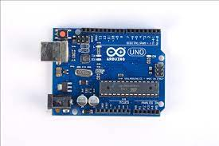

What is it?

* An electronics board containing a microcontroller chip (ATmega328P, an 8-bit microcontroller with 32KB of flash memory and 2KB of RAM) and other components like input/output pins, power supply, and communication interfaces.

* Designed for beginners and hobbyists to create electronics projects like robots, sensors, and interactive displays.

* Simple to use with the Arduino IDE, a programming environment with pre-written code examples and libraries.

Key features:

* 14 digital input/output pins (6 can be used as PWM outputs) for controlling LEDs, motors, and other devices.

* 6 analog input pins for reading sensor data like temperature, pressure, and light.

* USB connection for programming and powering the board.

* ICSP header for advanced programming and expansion.

* Reset button to restart the program.

Why use it with Arduino?

* Arduino provides a user-friendly software environment for writing code and uploading it to the UNO board.

* Large online community with tutorials, projects, and troubleshooting resources.

* Wide range of sensors, actuators, and other components compatible with Arduino.

* Relatively inexpensive and easy to set up.

Capabilities:

* Programming: The Arduino IDE (Integrated Development Environment) allows you to write code in C++ and upload it to the UNO R3. This code controls the behavior of the connected electronics.
* Interfacing with Electronics: You can connect various sensors, actuators, displays, and other components to the I/O pins and control them using your code.
* Prototyping and Project Development: The UNO R3 is ideal for building simple projects like blinking LEDs, reading sensor data, controlling motors, and more. It can also be used for more complex projects like robots, weather stations, and home automation systems.

Applications in Crash Severity Detection Systems:

The UNO R3's capabilities can be leveraged in various ways for CSDS:

* Data Acquisition:

Connect sensors like accelerometers, gyroscopes, and magnetometers to capture data on vehicle movement, impact forces, and orientation during a crash.Use analog-to-digital converters (ADCs) to convert sensor readings into digital signals for processing by the UNO.

* Data Processing and Analysis:

Implement algorithms on the UNO to analyze the acquired data in real-time.

Calculate metrics like G-force, change in velocity, and vehicle roll/pitch to estimate the severity of the crash.

* Communication and Alerting:

Connect the UNO to communication modules like GSM or LoRaWAN to transmit crash data to emergency response centers or cloud platforms.

Trigger alarms or activate warning lights based on the calculated crash severity.

Advantages of using UNO R3 in CSDS:

* Cost-effective: Affordable compared to specialized crash detection hardware.
* Flexibility: Can be customized with various sensors and communication modules for specific needs.
* Portability: Compact size and battery power options make it suitable for field deployments.

Impact Switch Collision Switch Sensor Module

The Impact Switch Collision Switch Sensor Module for Arduino (also known as a crash switch) is a simple but effective sensor for detecting collisions and sudden impacts. It can be a valuable component in a crash severity detection system for several reasons:

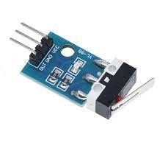

Functionality:

* Binary output: The sensor outputs a low or high voltage signal depending on whether it detects a collision. This makes it easy to integrate with Arduino for further processing.
* Sensitivity adjustment: Some models allow adjusting the sensitivity threshold, enabling detection of varying impact forces.
* Compact and lightweight: The module is small and easy to install in various locations on a vehicle.
* Low power consumption: Makes it suitable for battery-powered applications.

Applications in Crash Severity Detection:

* Collision detection: The primary function is to trigger the system upon any impact, initiating data recording and analysis.
* Impact magnitude estimation: By combining the sensor output with data from other sensors like accelerometers, the system can estimate the force and direction of the impact.
* Early warning indicator: Detecting minor collisions can alert the system to potential danger, even if airbags are not deployed.
* Crash location identification: Multiple sensors can be placed on different parts of the vehicle to identify the area of impact, providing valuable information for first responders.

NEO-6M TTL GPS Module with EPROM

The NEO-6M TTL GPS module with EPROM is a powerful tool with potential applications in crash severity detection systems. Here's a breakdown of its features and how it can contribute to this technology:

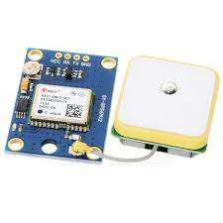

Features of NEO-6M TTL GPS Module with EPROM:

* Supports multiple GNSS constellations: GPS, GLONASS, BeiDou, Galileo for accurate positioning even in challenging environments.
* High accuracy: Typical position accuracy of 2-3 meters, crucial for precise accident location identification.
* Low power consumption: Ideal for battery-powered devices used in emergency response.
* TTL (Transistor-Transistor Logic) interface: Simplifies integration with microcontrollers and other embedded systems.

EPROM (Erasable Programmable Read-Only Memory): Allows customization of the module's configuration and functionality for specific applications.

Applications in Crash Severity Detection Systems:

* Accident location tracking: The GPS module can pinpoint the exact location of the crash, enabling faster emergency response and improved accident reporting.
* Vehicle speed and direction measurement: By recording the vehicle's position over time, the module can calculate its speed and direction before and during the collision. This data is critical for severity prediction algorithms.
* Time synchronization: The GPS module provides accurate timestamps for all recorded data, ensuring consistent analysis and reconstruction of the accident sequence.
* Data logging and storage: The EPROM can store essential crash data like position, speed, and timestamp, enabling later analysis and investigation.

Robodo SEN38 Force Sensor Resistor

The Robodo SEN38 is a versatile force sensor resistor specifically designed for measuring impact forces in various applications, including crash severity detection systems (CSDS). Here's a closer look at its features and how it contributes to this crucial technology:

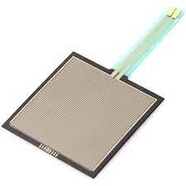

Features of the Robodo SEN38:

* High sensitivity: Detects even small impact forces with high accuracy, making it suitable for capturing the initial stages of a collision.
* Wide force range: Measures forces ranging from a few grams to hundreds of kilograms, accommodating diverse crash scenarios.
* Fast response time: Provides real-time data on the force and timing of an impact, crucial for immediate response in CSDS.
* Compact size and lightweight: Easily integrates into various locations within a vehicle without adding significant weight or bulk.

Applications in Crash Severity Detection Systems:

* Vehicle front and rear bumpers: Measures the initial impact force to estimate the severity of the collision and trigger airbags or other safety measures.
* Door panels and side skirts: Detects side impacts and helps determine the risk of occupant injuries.
* Engine compartment: Monitors impact forces on the engine and surrounding components to assess potential damage and fire hazards.

Large-scale implementation of Crash Severity Detection Systems (CSDS) requires a multifaceted approach encompassing several key areas:

1. Technological Infrastructure:

* Sensor integration: Develop standardized protocols for integrating various sensors (cameras, radar, LiDAR) into vehicles and infrastructure for seamless data collection.
* Communication networks: Establish robust and secure communication networks for real-time data transmission between sensors, processing units, and emergency response centers.

2. Algorithm Development and Training:

* Data collection and labeling: Build extensive datasets of real-world accident scenarios with accurate severity labels for training and refining machine learning algorithms.
* Algorithm development and optimization: Continuously improve the accuracy and robustness of severity prediction algorithms through research and development efforts.

3. Economic Feasibility and Incentive Mechanisms:

* Cost-benefit analysis: Conduct thorough cost-benefit analyses to justify the investment in CSDS implementation and demonstrate its potential impact on accident reduction and cost savings.
* Incentive programs: Offer financial or regulatory incentives to manufacturers and consumers to encourage the adoption of vehicles equipped with CSDS technology.